**Finish a project management application**

I bought Worksuite (<https://demo-saas.worksuite.biz/>) script in laravel to do a personalized project management software. So I made many changes to worksuite script but it is necessary add other features and make other changes or solve some errors to have a perfect application.

The software is based on two concepts:

* Analyze in detail the difference between estimate and real cost. For this reason I create some relations between estimate and project, task and timesheet. So the application have many report, pivot with drill down tables and charts.
* the application have a connect flow that start from estimate and go to time sheet to analyze all
* the software must be very, very user friendly and must have an excelelnt design

The principal features to do.

1. make better the navigation regard the the asignation of task and expences. It is simple change of links and datate of buttons.

2. make better the calender to asign the task to the employers

3. verify all initial report of worksuite to test if are ok or it is necessary make some changes to the formuals based on new database and informations.

4. Invoice regard the project. It i s neecessary adapt the features of invoice to new estimate information

5. change the menu, hide many informations inside the page, change banal things. To do this point fast and good it is necesasry navigate togheter all pages and make all chnage s necessary in reltime. The goal eliminate a banal errors and teh feature snot necessary to have auser friendly application. The changes of menu must be make regard administartor, superadministrator,client and employer of client.

6. Language. It is necessary use the italian in all web how default. So it is necessary that you send e the fle with english teext. So i make the tradution and resend to change. If some english text aren’t inside the files, it is necessary change manually.

7. verify the authorization regard the service and page to give the correct authorization to the meployer and client regad show or not show the page or change- It already work buti t is necessary make a test and if necessary make some changes

8. Design and CSS. It is necessary decide and change the design –css. It must be very user friendly and modern

9. solve all the feature regard to buy the a plan, registartion and payment because now there are plan, client informations, method of payent, but don’t work the flow to buy and pay the plan to use the application.

10. other small changes

Notes:

- To do some points (for example point 4, menu) I can explain the details of changes by anydesk. So you can do teh changes more fast or in realtime in your locla pc

- the images attach inside this document aren’t all changes to do. The images are only some expample of problems. For this by anydesk we can see all details and do all that banal chanegs necessary and make them in real time.

- at the end of job it is necessary the installation inside my host and made a final test

- Regard the design I want a semplify design and semplify information that the user see becuase the software must be used by small company and they must think that he can use the software also if he aren’t expert in use of pc. the color, the button and other must be modern, we can copy a little wethod ([www.wethod.cm](http://www.wethod.cm)) design, or if have other idea is ok.

- to do the changes, in particular regard the report, it is necessary value database if is good to have all reports, otherwise it is necessary change it

1. Task flow and informations of task (some features of this point are already made)

The users that have the authorization to asign the task must have do a fast flow and must see the correct informations regard the task. Now there are banals error that it is necessary change. So it is necessary change some buttons, links, hide some buttons.

In detail…

- it is necessary solve a problem regard the status of projetc. Now it is possible chnage the status fof projetc manaully. For some of them is, so for finished is ok, cnacelled is ok, but regrad the other adn in particular the status of asignation of stsatus must be automatic. what means. if i create a project the next ste is asign the task. When some tasks and expences are asigned (not all) the status became on hold; when all tasks and expences are asigne became “no started”. when some task have teh time sheet became “in progress”. 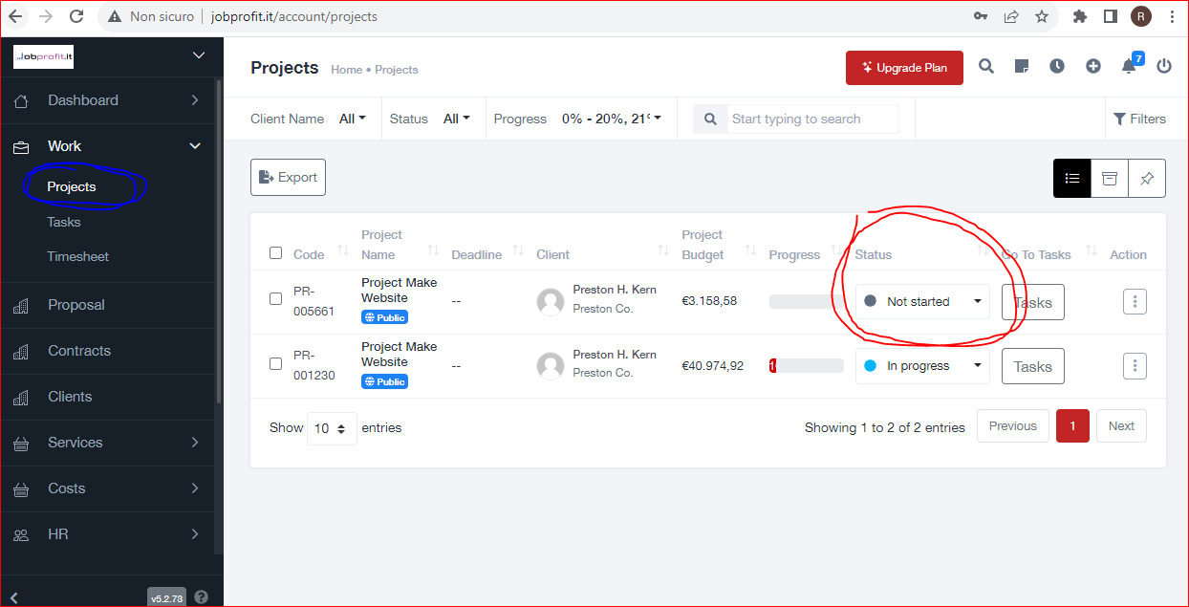

- Now the page “task” show not correct informations.

First it is necessary:

- Inside the page task when the user click on project row the software must show the list of task and expences with drilldown logic. Now open a new page and don’t show the expences of that task.

So in task page click on project (see 1) and the software must show the list of task and expences (see my paint 2)

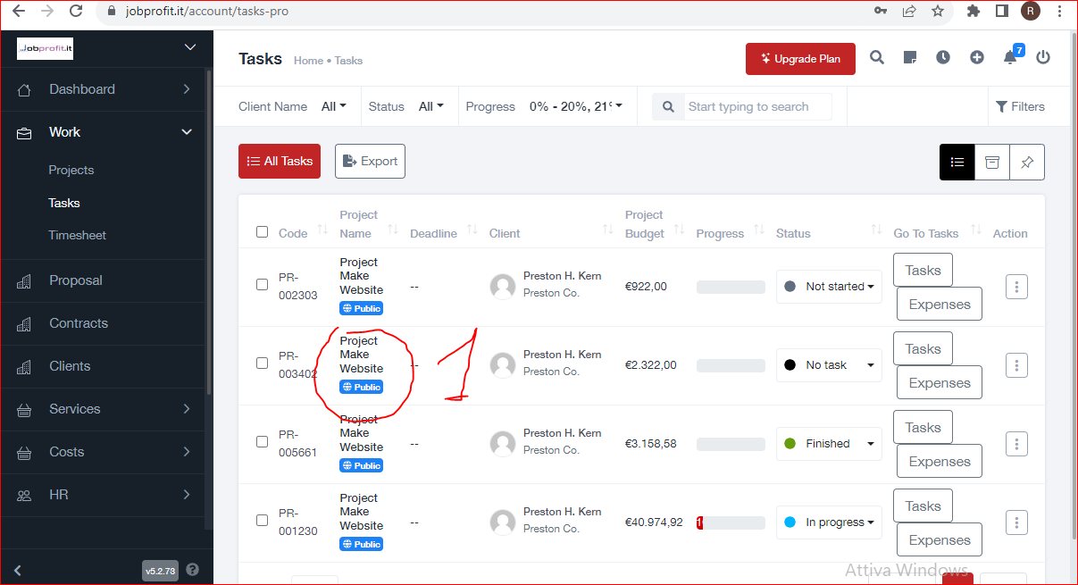

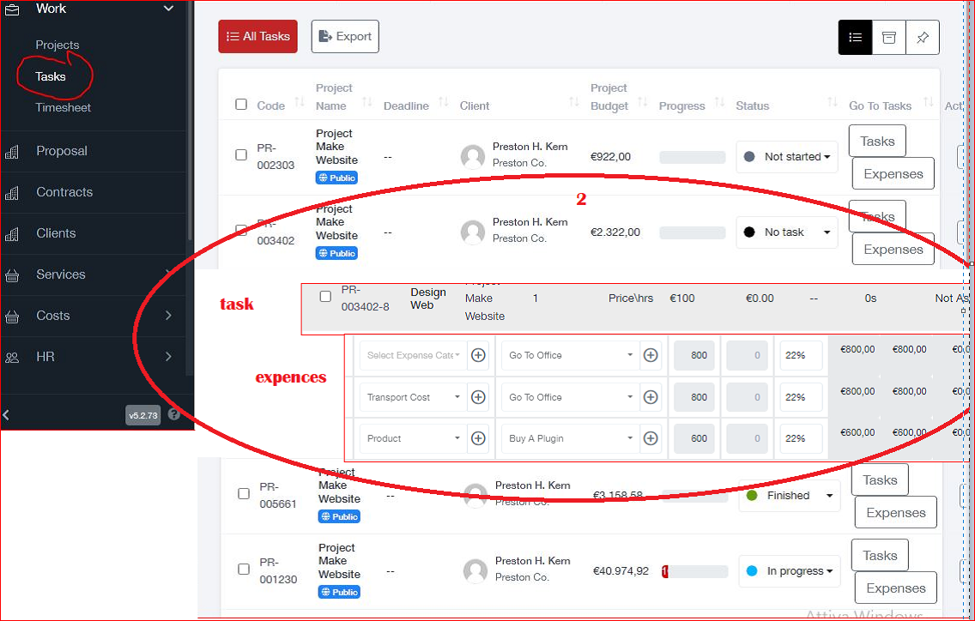

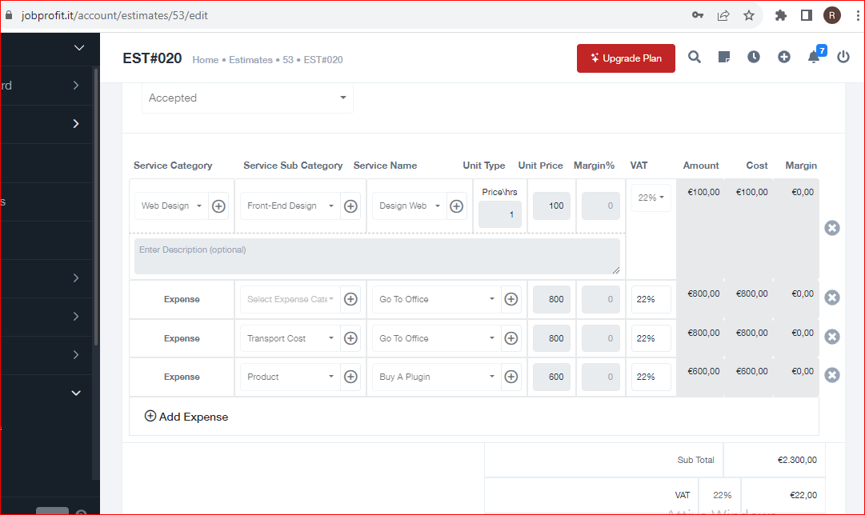

- and when click on row of task or expences the software must open the page task or expence in edit because isn’t asign still. now sho in view.

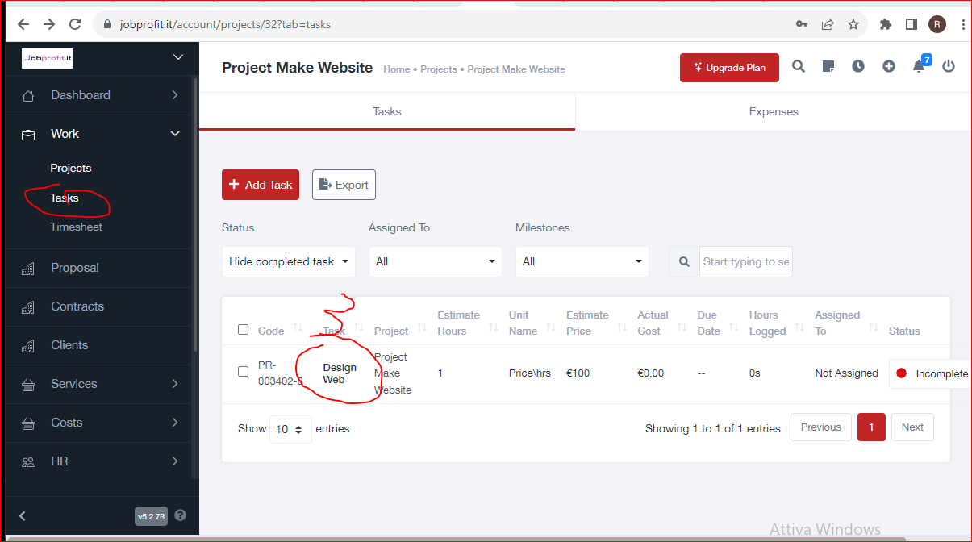

how you see now show in view

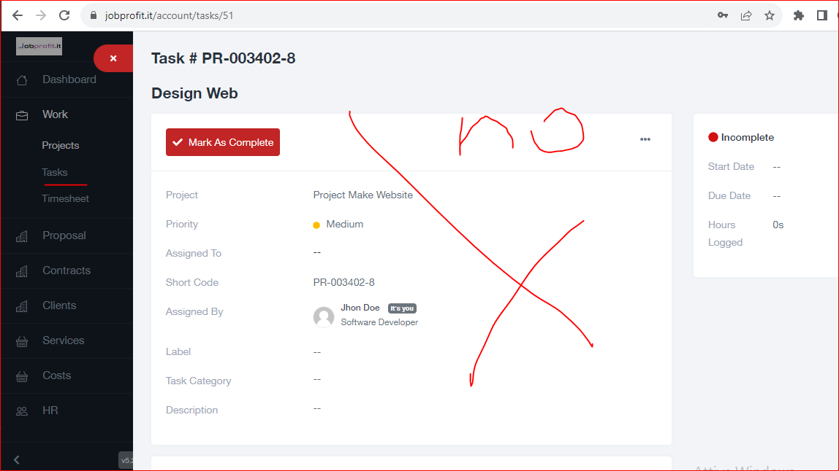

i want the edit page. see the folowing image, but withthe chenages that I explain after.

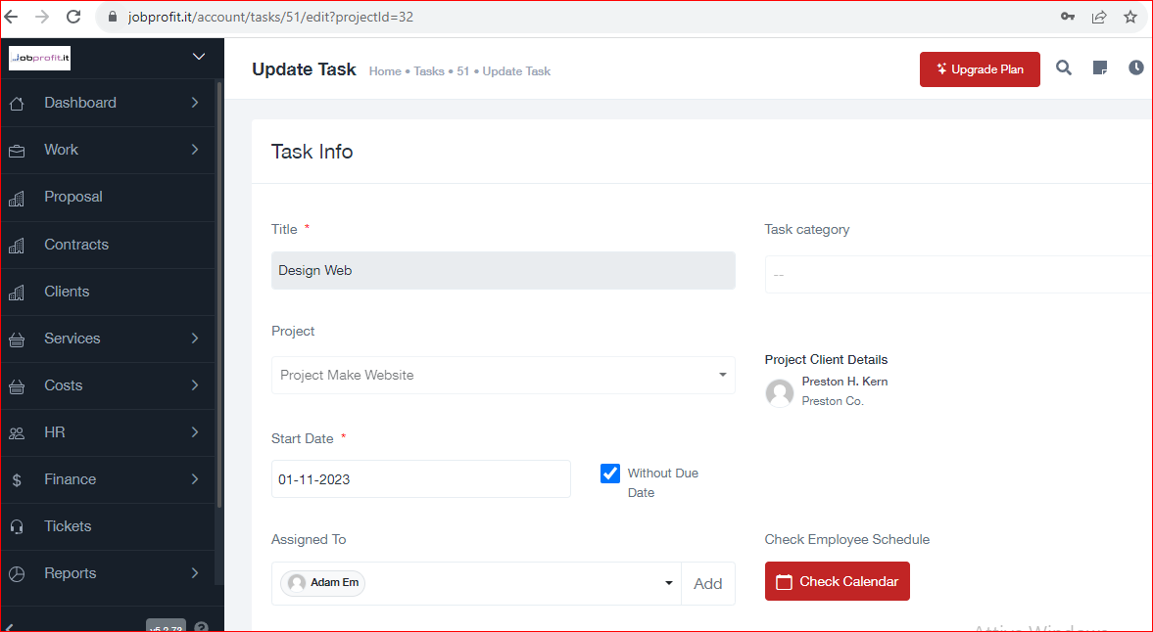

It is alos necessary eliminat eth link in project information of page task list

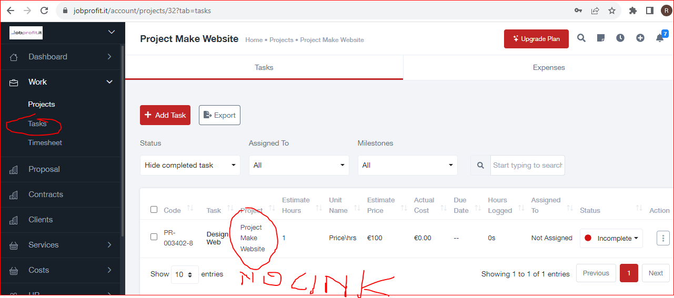

--drill down

so if you see the page “task”, if click on row of project (5), the software show the information of project how the page project (see 6). In this istuation the goal is asign and manage the task

In page “task” I don’t want what you se in image 6, but I want that the software with drill dow show the list of all tasks and expences of that task with status 8asigned, not asigned). and if I click on one tesk or expences i can go in the page of task do add or change

Other problem regard the specifc page to asign the task to an employer.

- first: now the prpose authomaticaly an employer how default. It on’t want this. So It is necessary eliminate the default employer (to verify if there is a setting of that default inside employer)

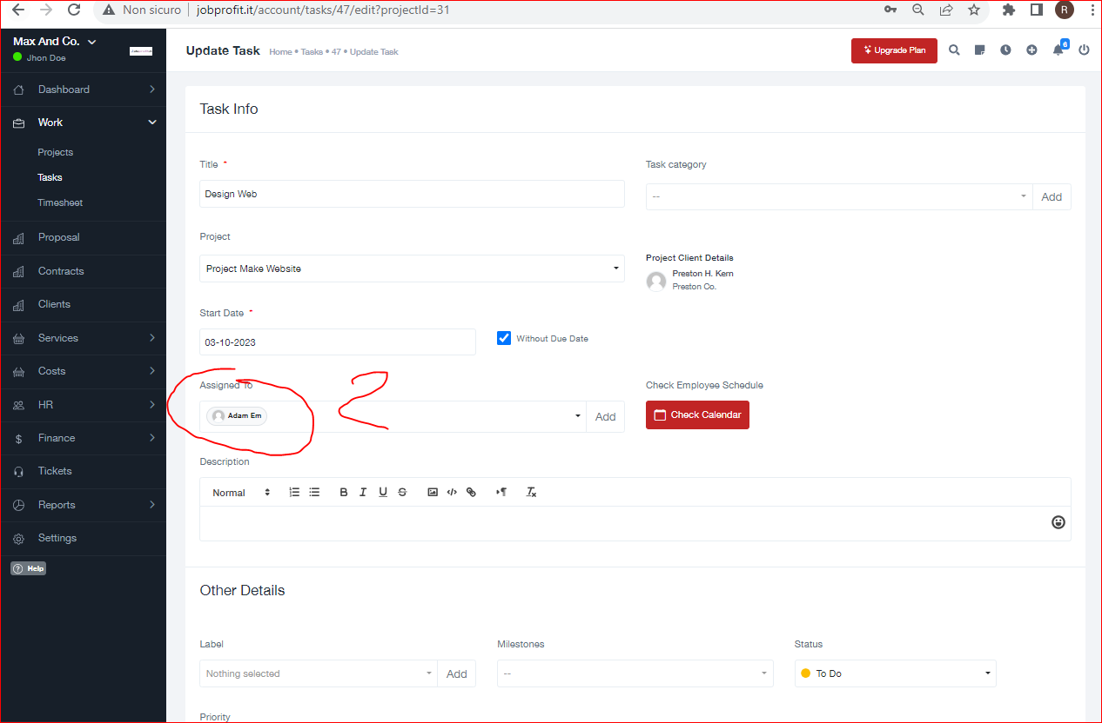

second: since the flow is selct project –select task means that when do insi deth edetails pf task it isn’t necessary select again the project, the service, so category and subcategory. But the software show that selection. So it is neecssray eliminate the selection and show only the information of project and service.

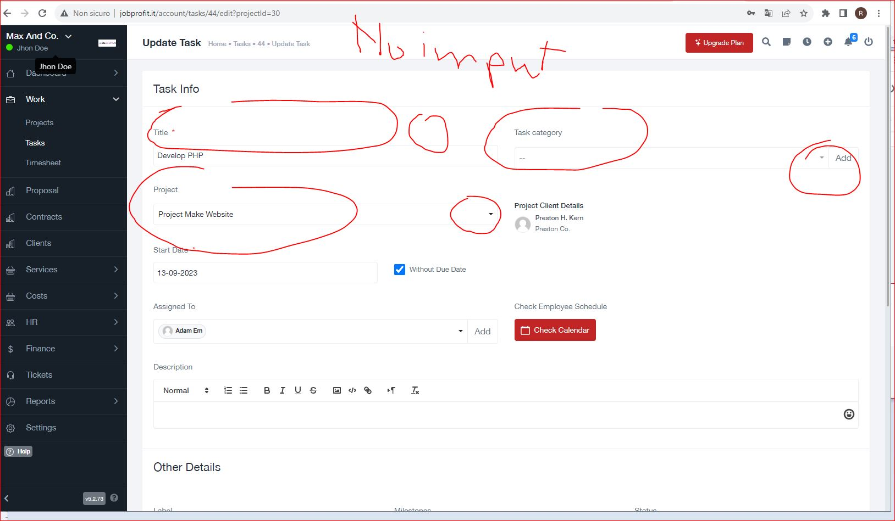

Attention this change must be made only if open the page “task” by list of task. If it must add a task (button + task) the selections the page must be the actual (so will bee two differnt pages).

Pratically if I click task by the following button, tha actual page is ok.

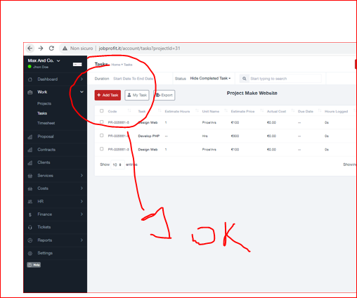

Note: It is necessary use the same logic for add expences. So also the page expences must have the same logic of page tasks

1. calendar (some features of this point are made)

Inside the page asign task now there is a button that open a popup with the calendar to see the task already asigned (see 1) and a pop up with date of calendar to input the data (see 2)

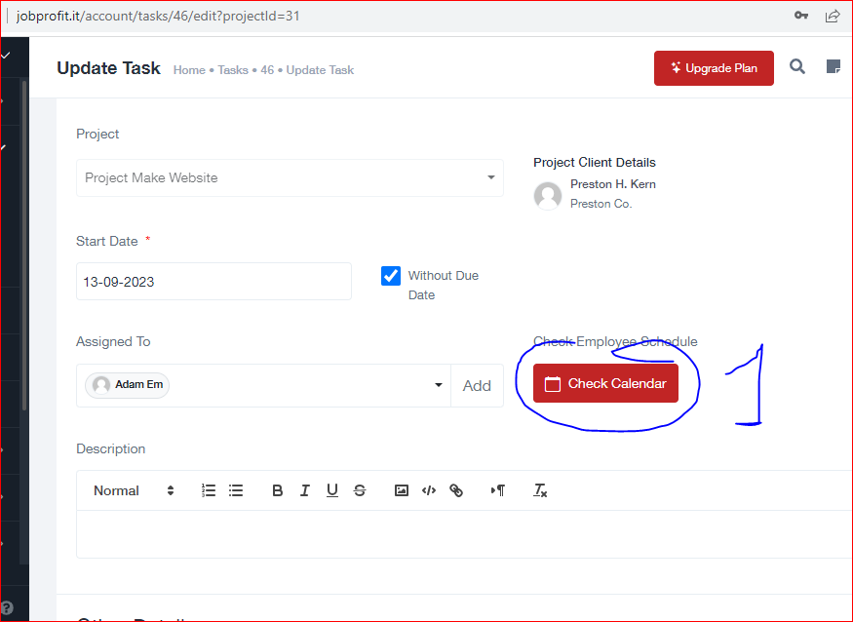

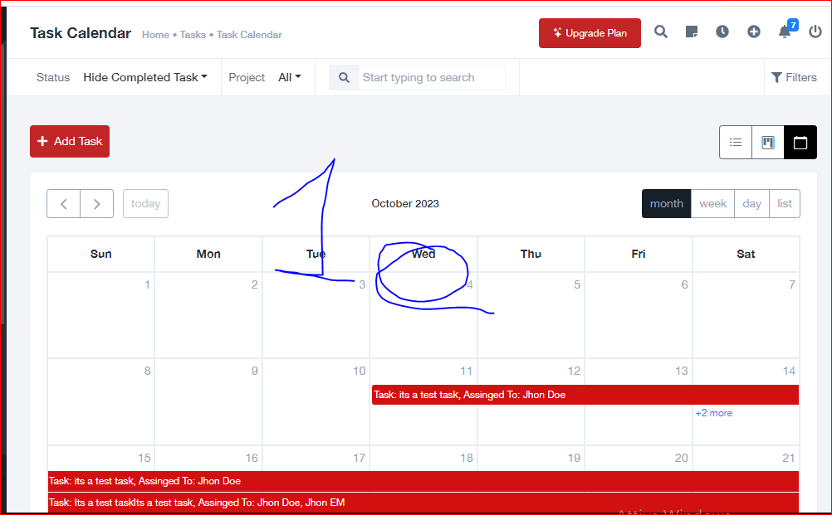

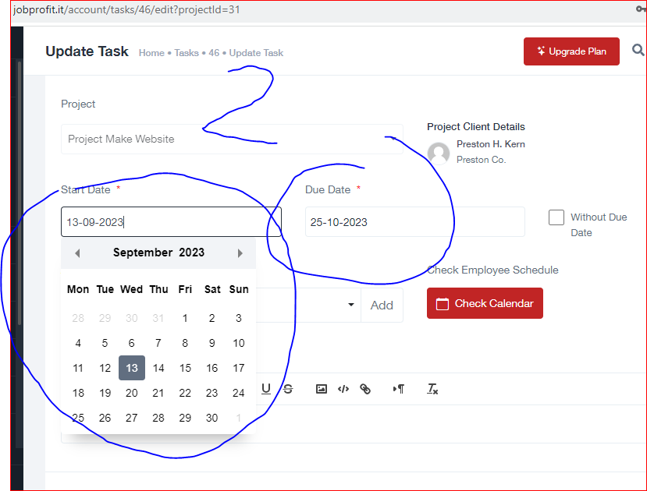

To select the data to start and the end data i want you change the calendar of image 2 with the calendar of image 1°. In this way it is possible see the employer free and select the data by that calendar.

Error. all page of task must have that method of selction. now the page creation of task don’t have

1. Report and pivot

The cocneptis that i want many report becasue the goal of software is mamake many analisys of tata. So the concpet is have report with drill down and with pivot logic to cross all informations.

To do this fetaures it is neecssary make a test togheyer and decide the method to useto solve fast.

What is the actual situation:

- a. the original script have some report, but now the informations of softwar are different and the databse was changed. So it is necessary make a test to decide what of them delate becsause not necessary and what id is neecsary chnaeg the the formulas;

-b. the new report creat by last developer. b.1: It is necessary make a check to verify if the formulas are ok; b.2 make small chnace of some of them; b.3 verify and if neecessary by the miti spossible go indetails of informtions, so drill dow to go to the specific service. If it is not possible itis neecssray add a picot scripts; b.4 it is neecssray make better teh design and use abetetr script f charst becaus enow are orrible (free script)

- c. it is necessay make an order of link of report because now are a little confuse.

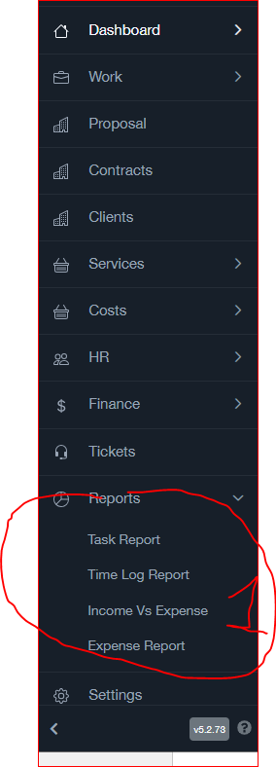 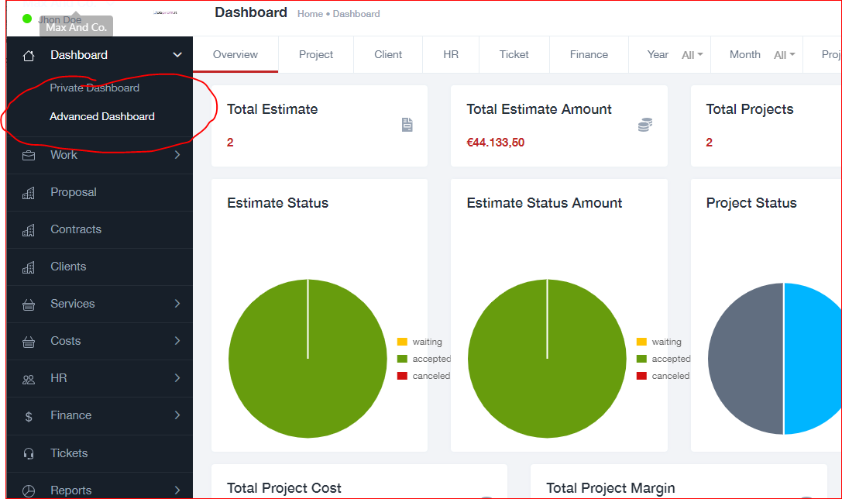

By the following image you see sm eregìport of design of a competitor that we can copy

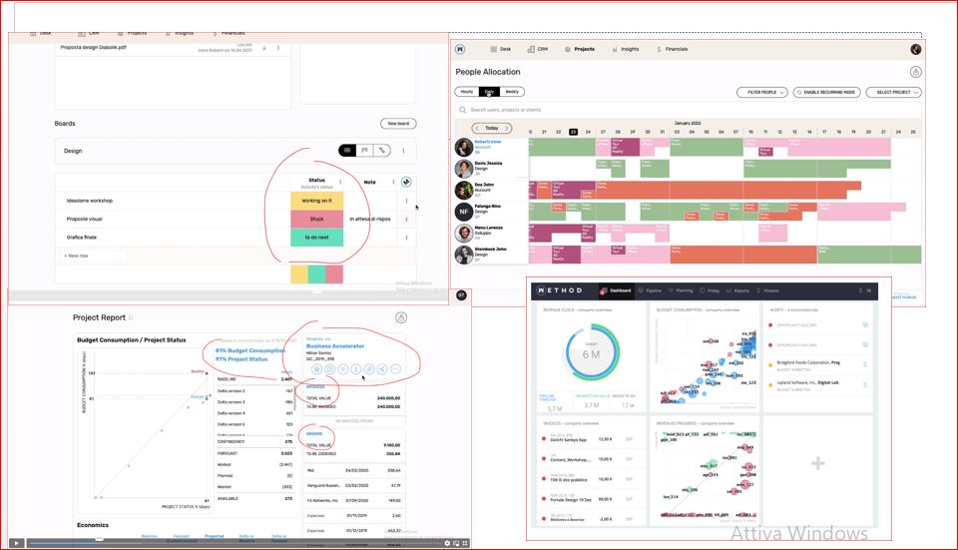

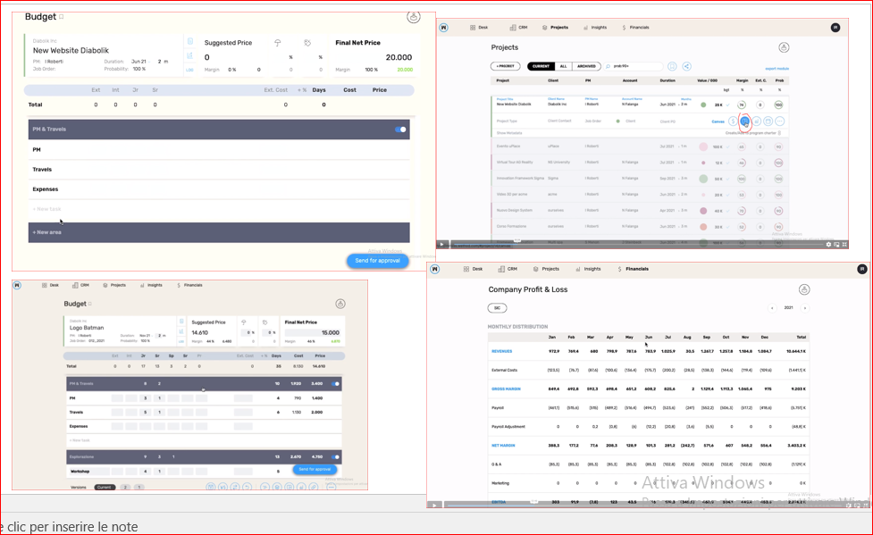

By the following image you see teh actula error that show teh application the easonfor many of tehm is that now there aren’t the input infrmations of project. So I tacch to see what we must verify and decide if chnage, if are ok or delate. many of them we can delate because i have the new reports

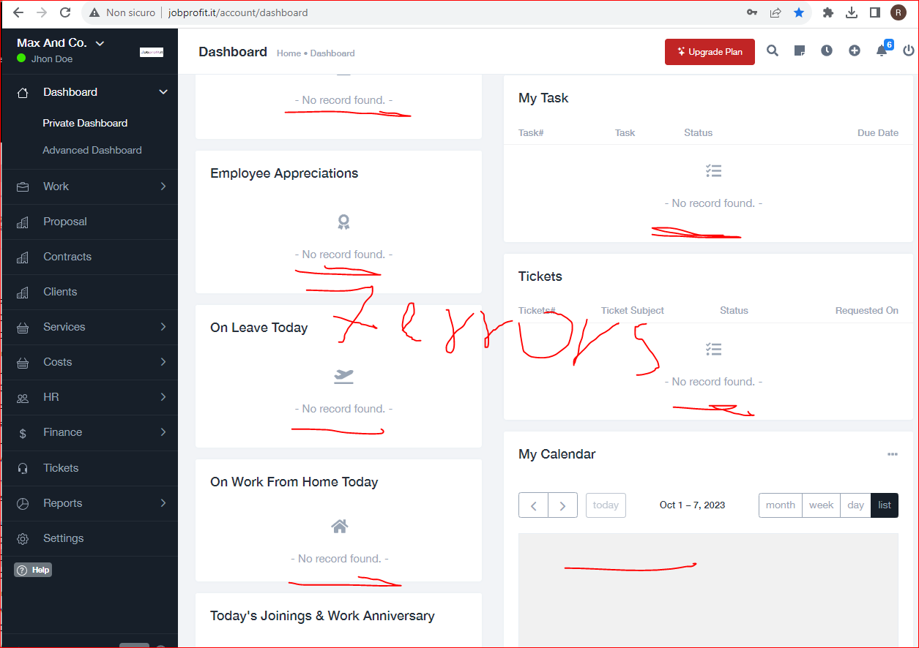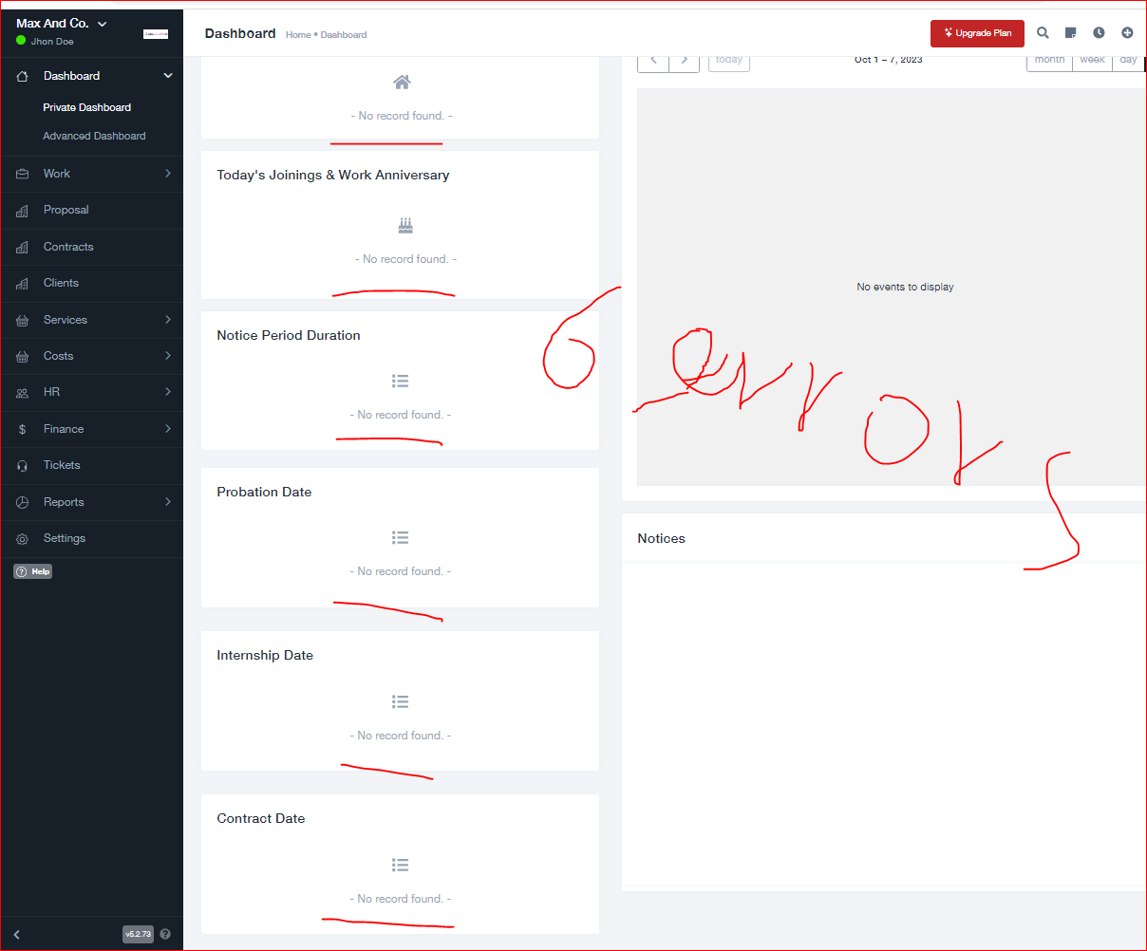 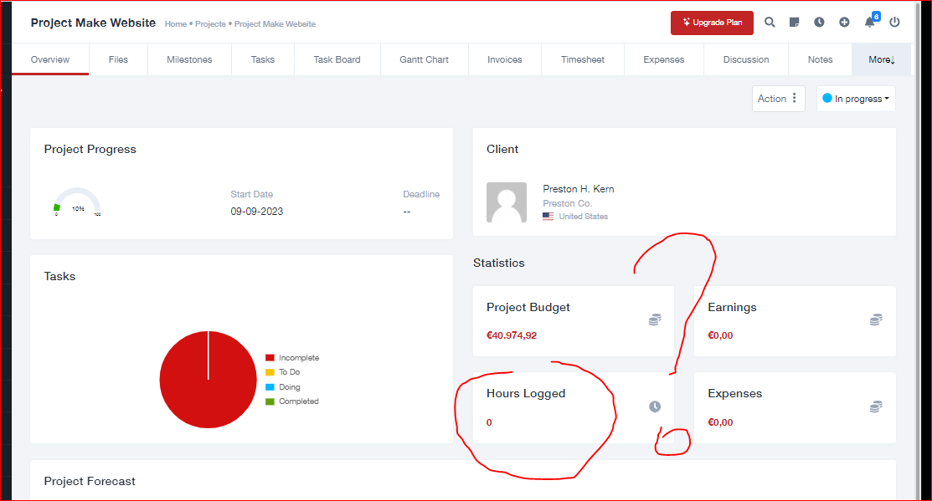

By following image you seethe new report. You can see that the design is orrible. The 90% of them are ok. it is only neecssray verify the drill down, so filter and the design. The goal:have correct value and the report must be understandable by everyone

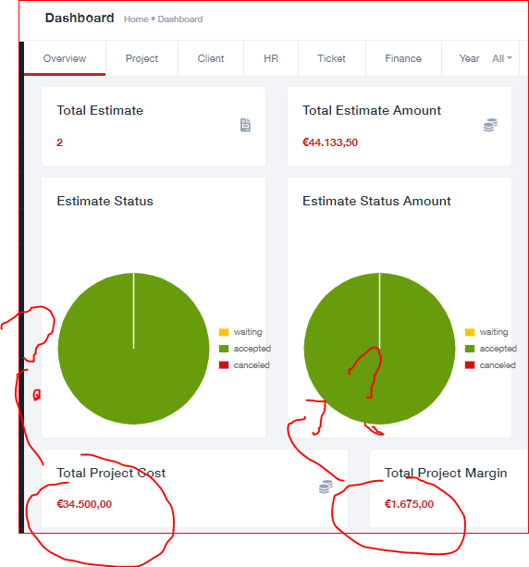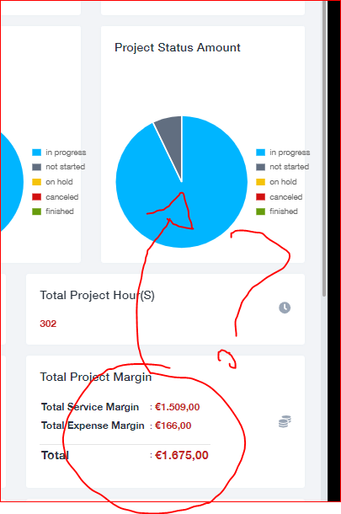

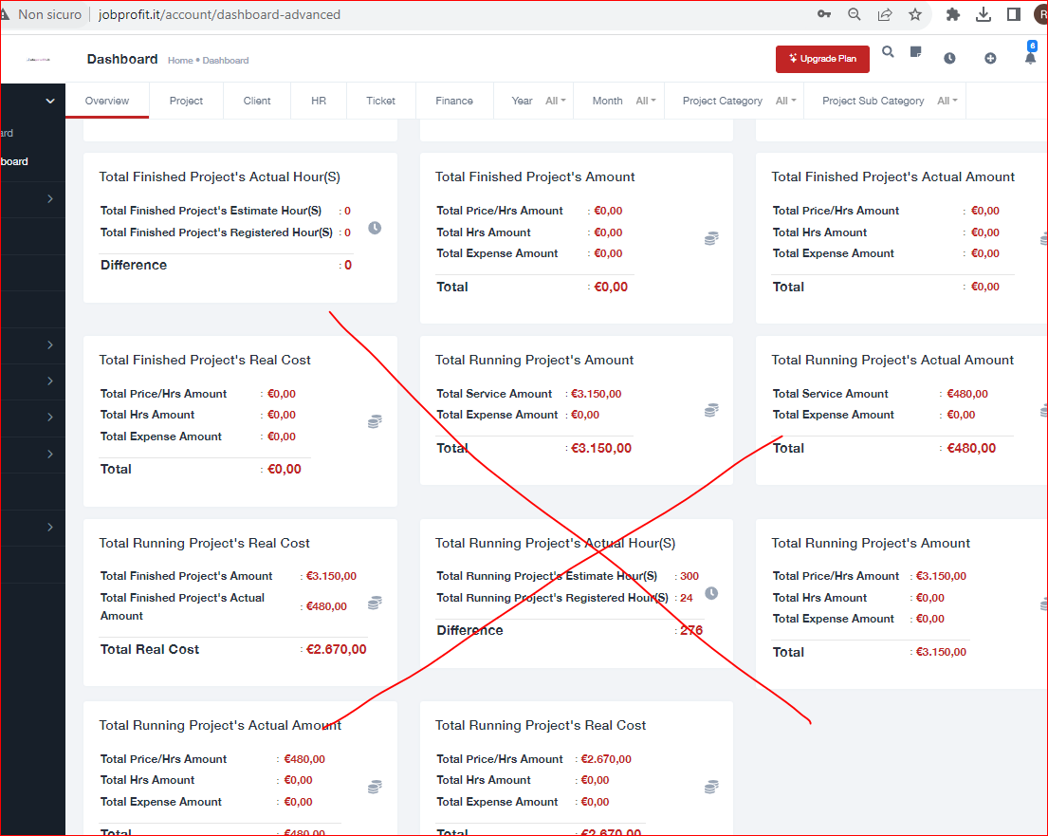

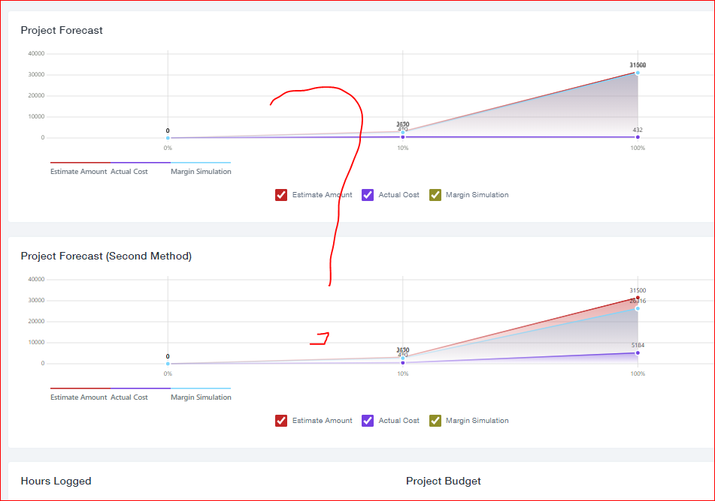

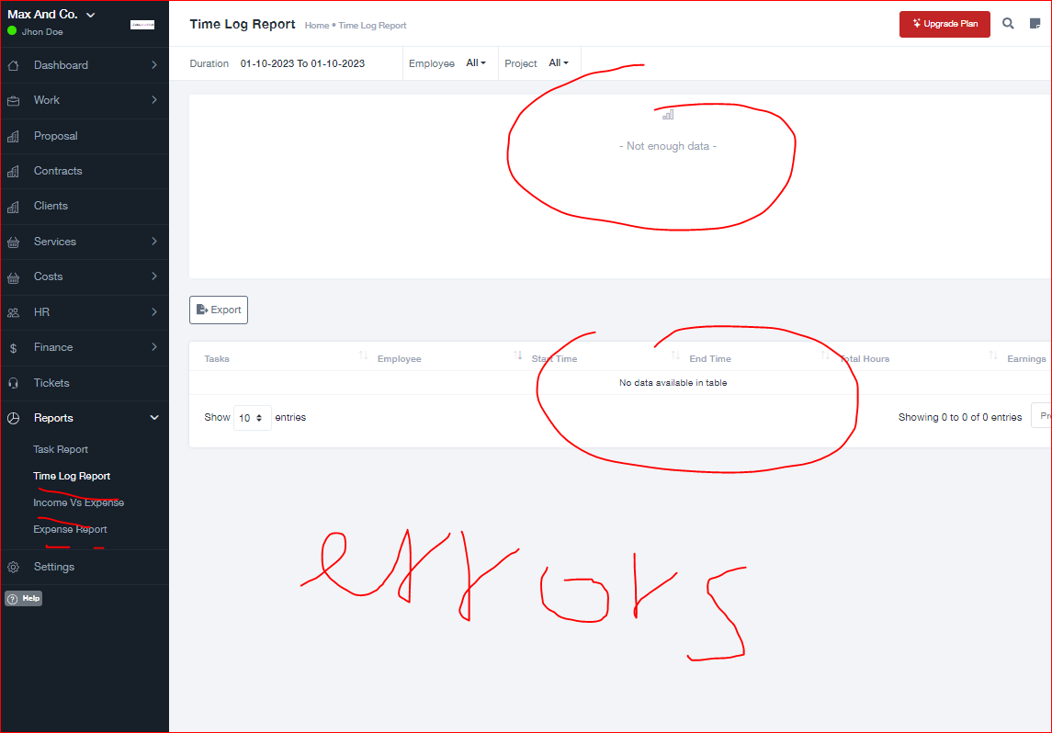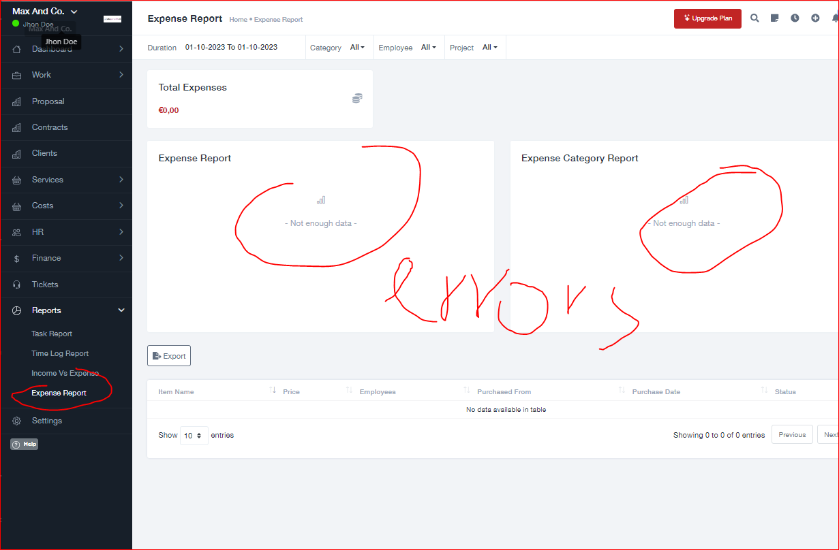

we must verify if worksuite have some report regard the invoice and difference betwwen estimate amount and invoice, but t is few important

1. invoice

Regard the invoice it is necessary adapt the invoice to new estimate and italian rule, so it is necassary make some change regard the creation of invoice and verify the value and of the formulas.

In particular it is necessary add first the selection of client or project opened. So it must possible select the service and the expences of that project withou t invoice, so it is possible add the correct information and correct value. It is also necessary add some information, for example the VAT and delate other infrmation, for example discount, shippig address, billing address

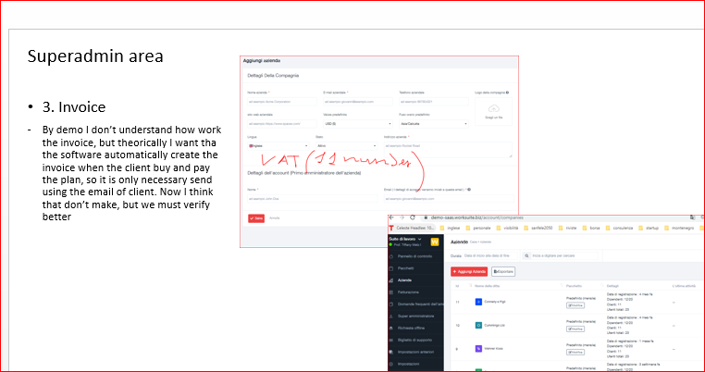

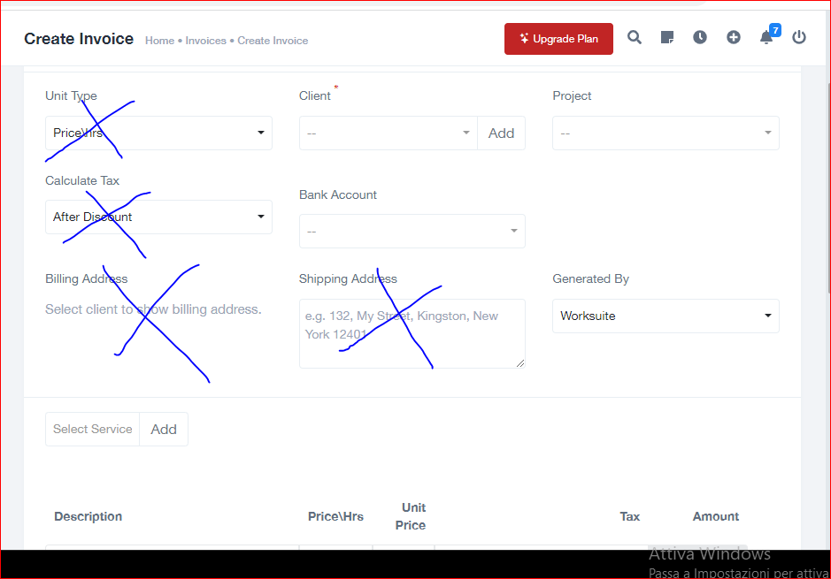

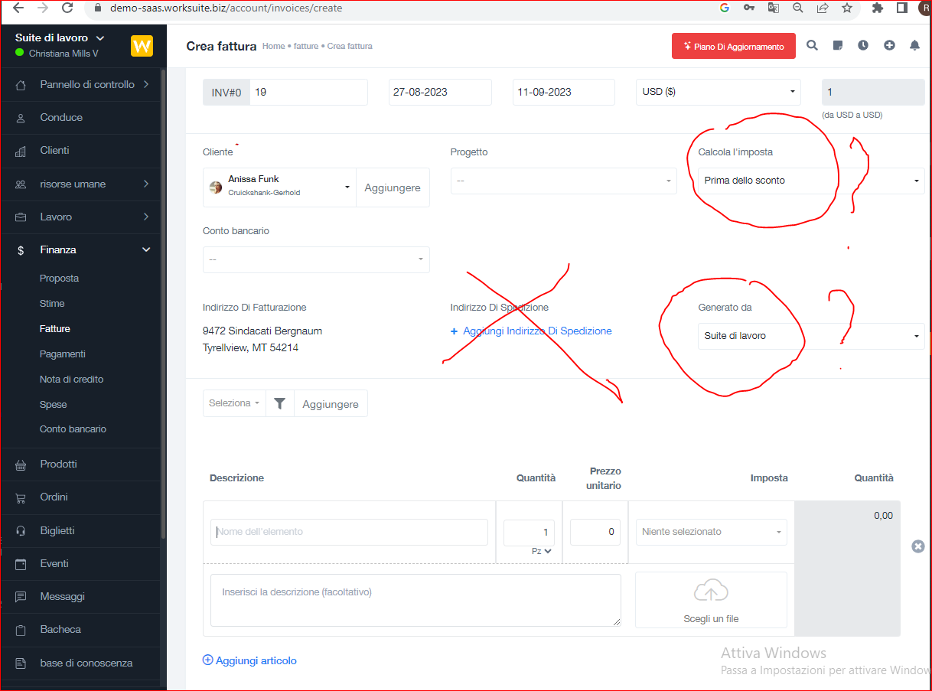

1. menu

I attach some example of change of menu. So in general it is necessary see togheter the application and decide a final menu, so delate some link, hide other, change the position. it is a features very simple. it is necessary make it for user, admin and superdmin. For admin and user itis importnat to smplify the navigation and to put inisie teh setting the link thai t is necessary use rarely

.. 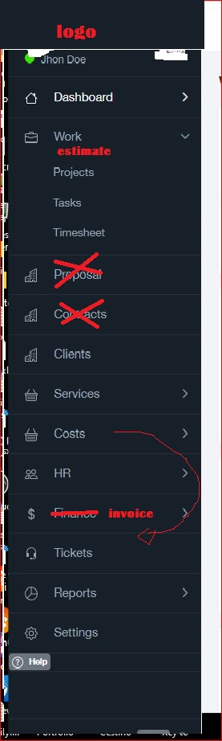 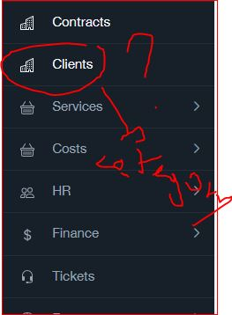 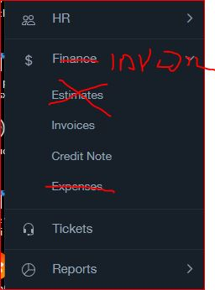

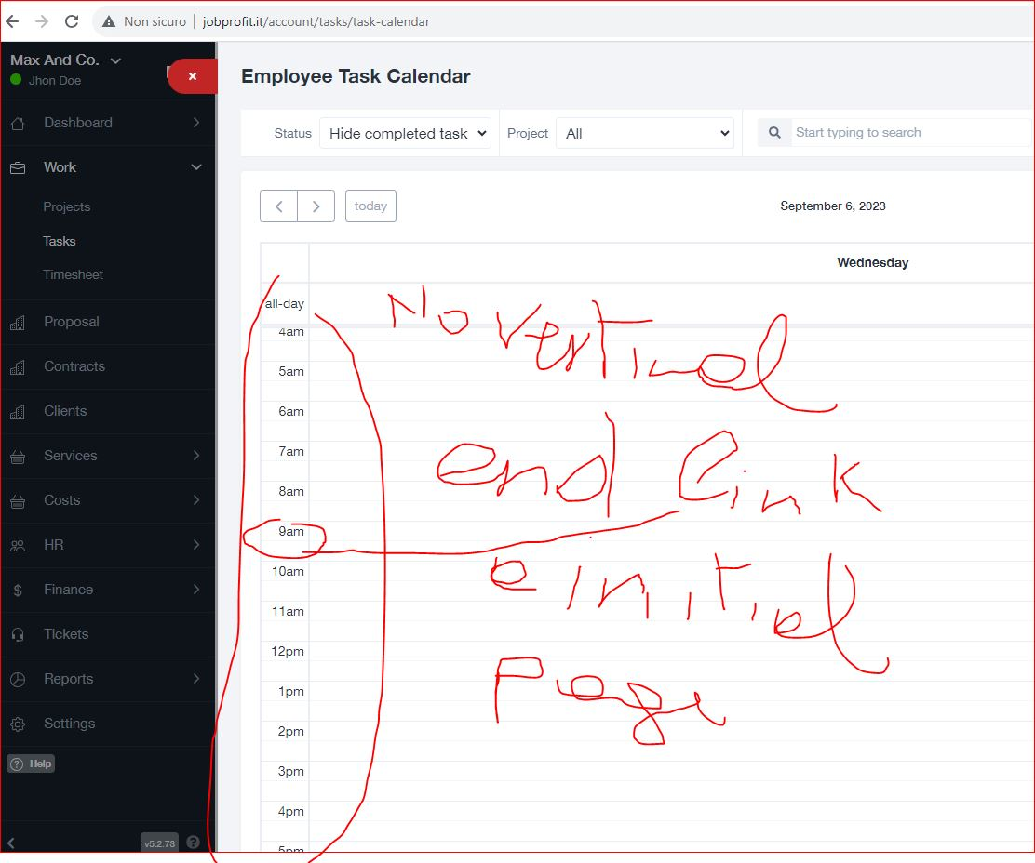 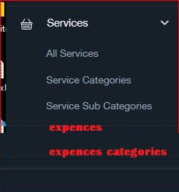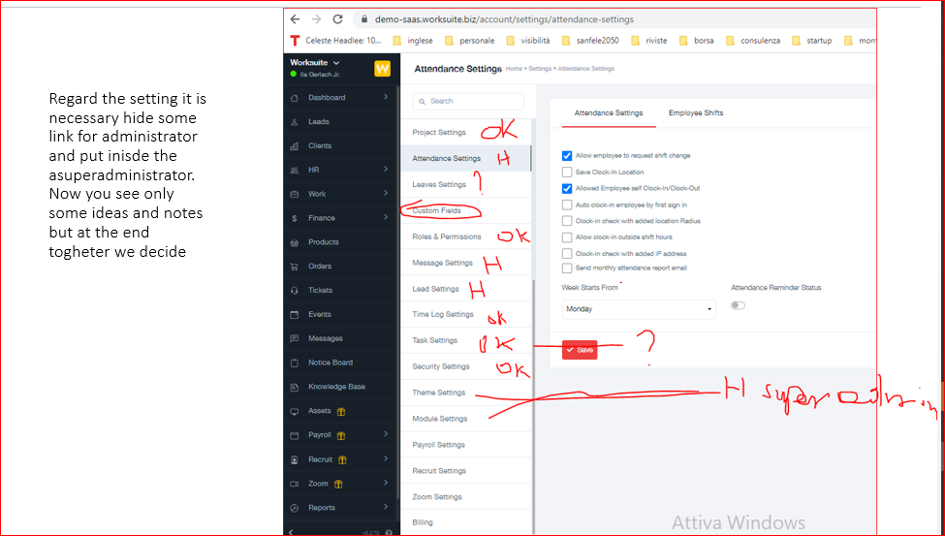

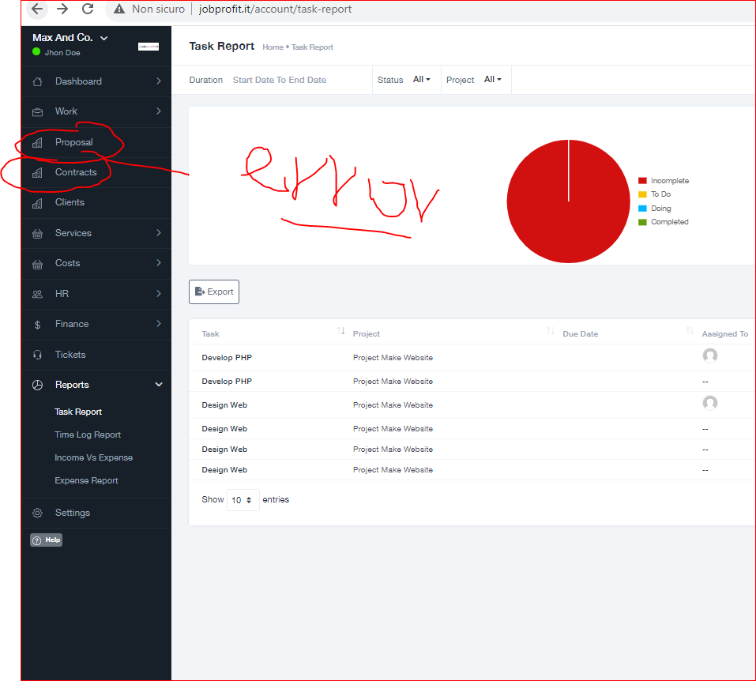

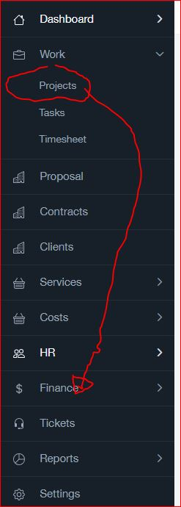

1. Language

- the software must have how default the italian language.

So it is necessary use how default all page that show now the english selection, for example creation of new client or creation of new employer. So all page must have the italian.

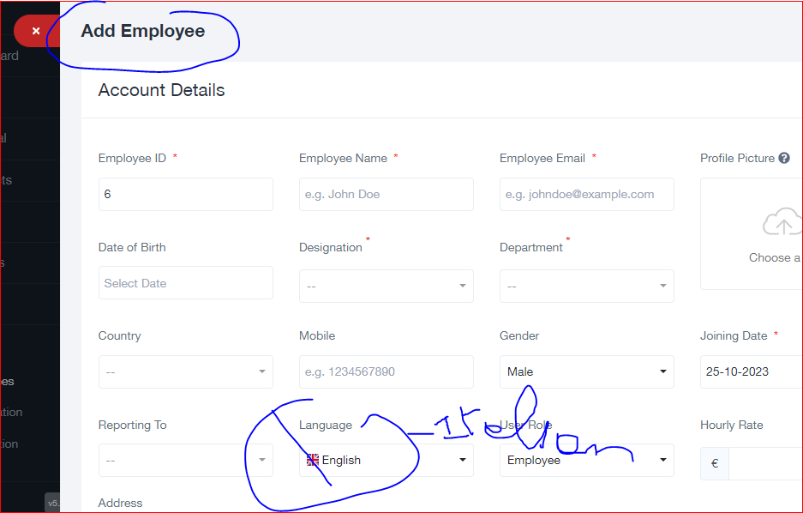

Also all text of all page must be in iatlian. so it is necessary that you send me al file with texts, so i can do the tradution to changes. if some texts aren’t inside the file, it is necessray schange manually.

7. verify the authorization regard the service and page to give the correct authorization to the employer and client regad show or not show the page or chnege- It already work buti t is necessary make a test and if necessary make some changes

1. Design and CSS. It is necessary decide and change the design –css. It must be very user friendly and modern. My idea is use a style of [www.wethod.com](http://www.wethod.com) or <https://www.webank.it/webankpub/wbresp/calcolatore_mutuo.do?gad=1&gclid=Cj0KCQjwpompBhDZARIsAFD_Fp_NG76trKNjvppg8ElnFZKvkLOCtKCI3G5LqnDUTkg1l7qJwWHDczcaAjlLEALw_wcB&gclsrc=aw.ds>. Regard Wethod you can see teh images attache inside the point of report

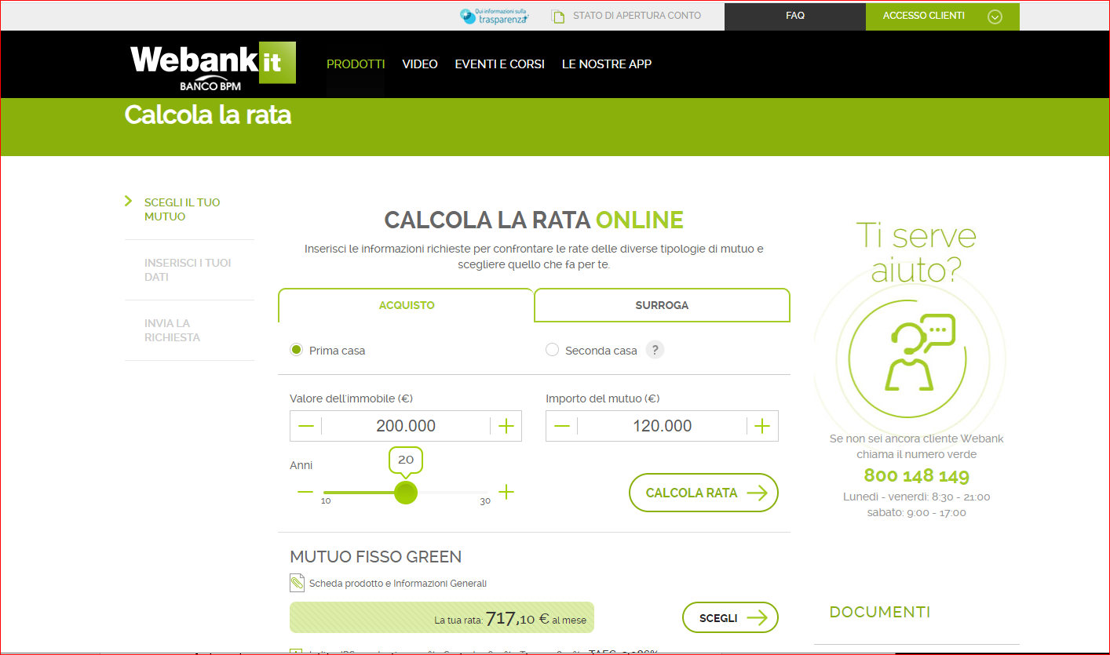

So regard the design it is neecssary create uniformity of button, userfriendly naigation and modern design.

We can decide to use one of more template that the softwar have and make specific change or use an other.

In the first situation it is necesray make some few chanags, for example logo, button, etc.

I attach the actual theme setting. 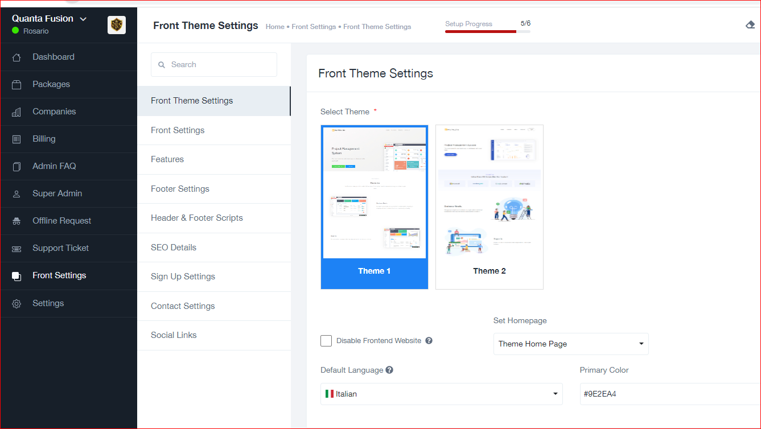

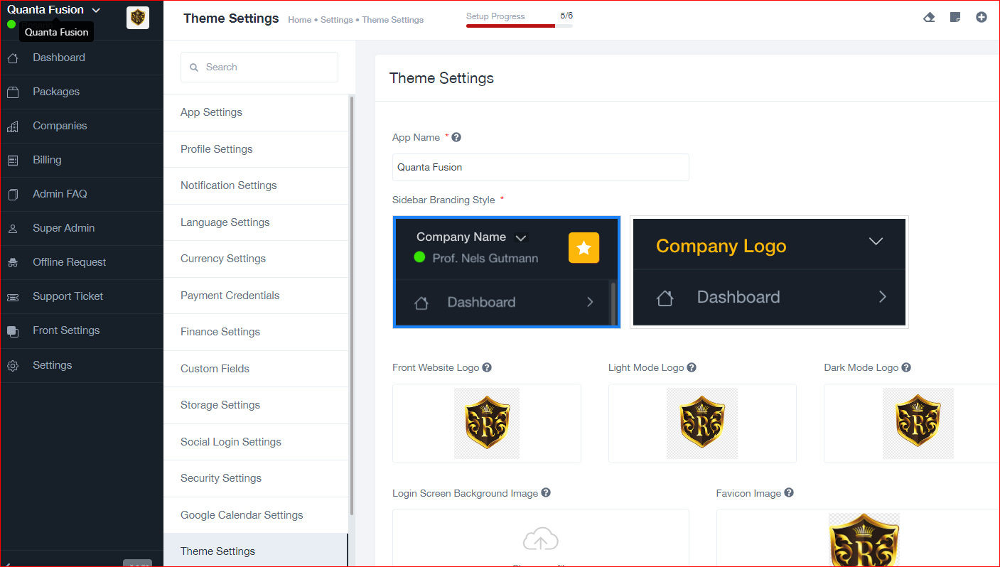

1. registartion and payment

The original script have already all features regard the plans and the payment, but it is neecssary make the setting to create the condition to work perfectly. Infact now tehe page don’t show the button of pyment and have a long list of service. So it is necessary hide some of them because my application don’t have. And it is necessray add the button and create the connection regard the egistartion of clients and cration of login to complete teh payment. It is clear that that login cna be used to use the application. Logic Saas.

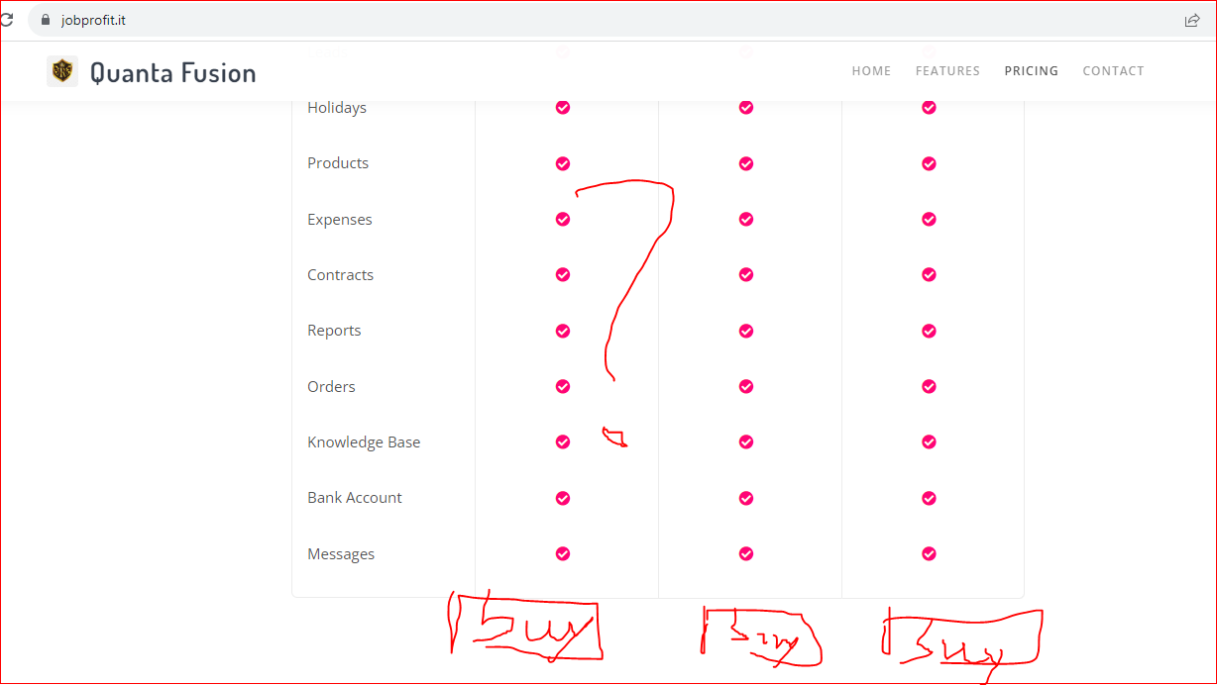

To undestand the features that already the software i attach some page of superadministrator

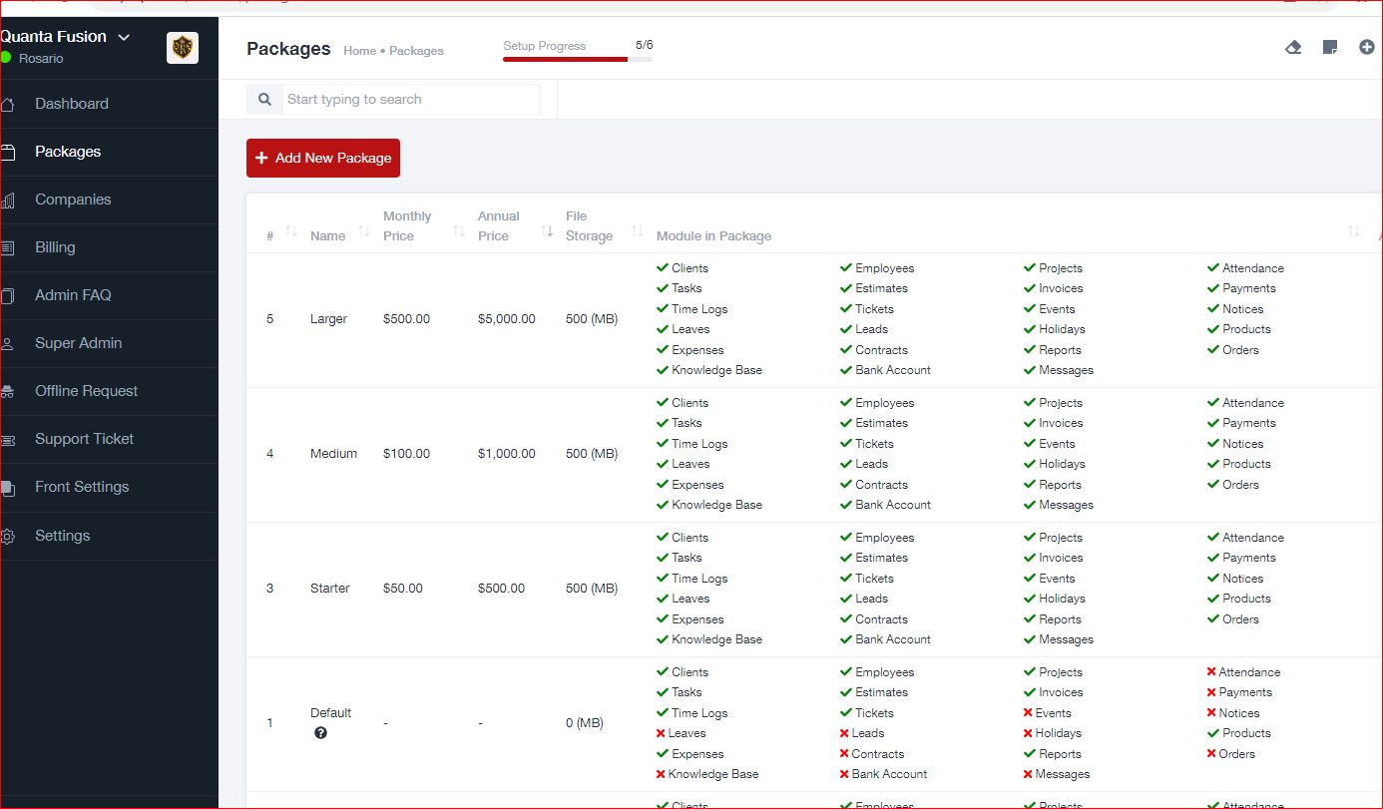 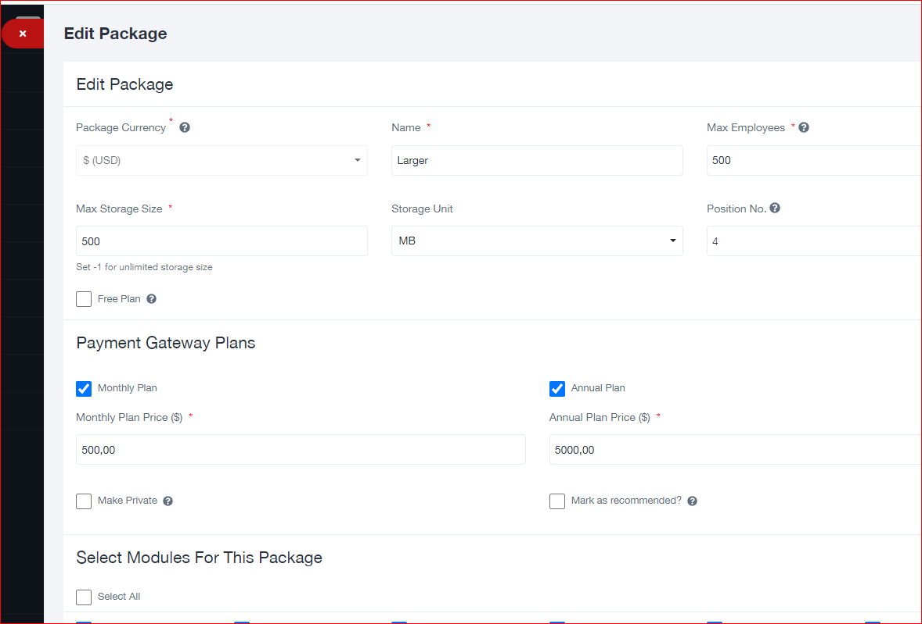

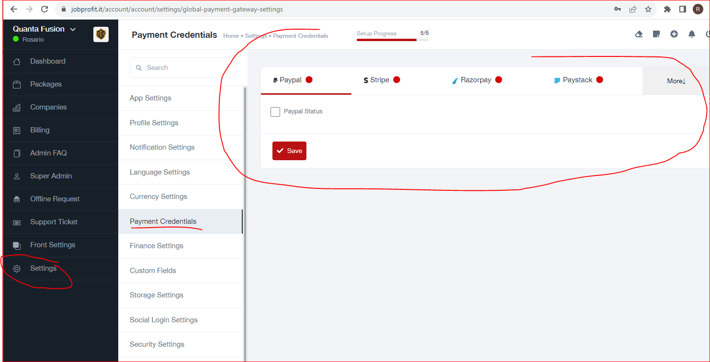

10. other small changes

- setting how default the value in €.

- change some text of fetaures, link and othe not correct.

- use my logo inside the application, so the logo of clentmust be used only for the invocice

- buttons. I think that the button of home page are good. If we decide to use them, we must use teh same style in every pages of applications. I think that the insid epages don’t use the same, but after i will verify.

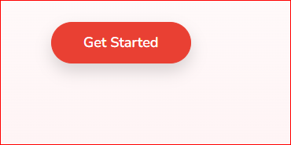

- Font. We can use the actual font, but I want more big the size. I think that to decide we must value the inside page if can use more big font size

colors login: must have the color of logo

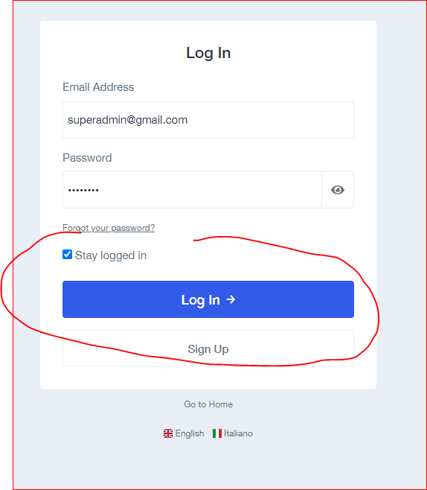

button have orrible design

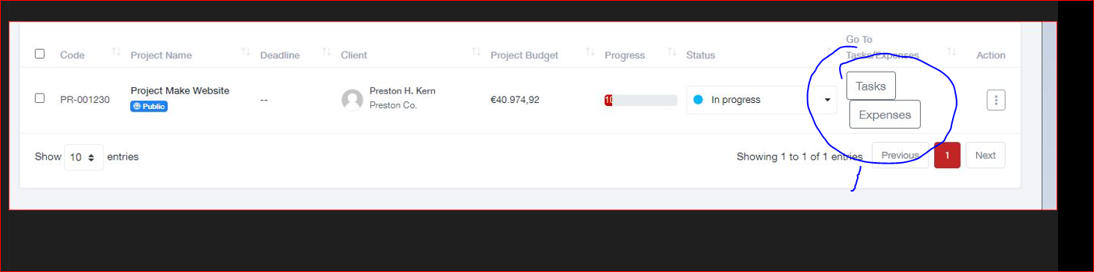

- make better design of following box and change order and add some informations (value of estimate and formulas using general cost). after I explain in detail

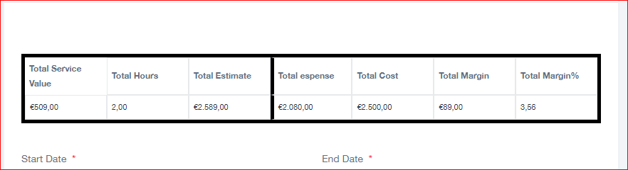

At the end it is neecssary navigate the application to verify if ar enecessray otehr small chnage, hide some not importat informations an dverify if al lis perfect.

To navigate the original application go to: :

https://demo-saas.worksuite.biz/login

**Very Important conditions:**

1. max budget: 100$ (the price is fixed, so it is not possible increase) to do all points. The payment must be in one solution at the end, so after put the code on my server and after that the test is ok (so no intermedian payment). The budget include all, so the application must withour error and must have perfect design. The budget include the installation on my server. The payment will do only if the test on my server is perfect. The budget is rigid.
2. job deadline: stimate time 3 days (the deadline is flexible, but I want see every day the progress).
3. I can award only after demostration that have that the developer have the competence. So it is necessary make a proof (solve some points of project and send me by video). If the proof is ok, I will award
4. before acept it is necessary to study every detail of document and project and ask me doubts, because after acept I don't want to read any kind of excuses and lies and I don't accept requests of more money
5. If all conditions are ok, I will send the code to start the proof